# Technical Documentation

## Project Overview (Purpose and Scope)

I work as a programmer for Omega Solutions who develop software for clients. I have been asked to design, create and test the software to access an external database. The interface to the database must enable the user to do the following:

•        display individual records

•        add a new record

•        delete a record

•        edit a record

•        update a record

•        cancel amendments for a record

•        search records.

A database already exists named Hire containing a table tblCar which contains car details. I am required to design and create software to access an external database (Hire) with a single table via a database connection and a data form. The main features of the program are two form files: frmCars and frmSearch.

## Connection Details

* Wizard

The first part of the program was created in Wizard through our DB file. I did create and edit data sources by using the Data Source Configuration Wizard in frmCars . After creating a data source, it appears in the Data Sources tool window.  In this form I did drag a data source from the Data Sources window onto a form design surface. There are tools available which are used in the from: DataSet, BindingSource, Table Adapter, AdapteManager, BindingNavigator, toolTip.

* OLEDB Connection String

The second part frmSearch uses the OLEDB Connection String and its connectors. OLEDB Connection String is a connectivity method to help bridge communication between client applications and a variety of data sources. Example:

OleDbConnection connectionToDB = new OleDbConnection(@"Provider=Microsoft.ACE.OLEDB.12.0;Data Source='C:\Users\RM281learner10\source\repos\AssignmentA\Hire.accdb'");

The OLE DB provider connection string is specified using the Connection String property of the OleDb Connection object we use OLE DB provider connection string that includes the data source name, and other parameters needed to establish the initial connection. OLE DB has two parts: provider and source. Example:

 Provider=Microsoft.ACE.OLEDB.12.0;

The "Provider = value " clause is required.

 Data Source=''C:\Users\RM281learner10\source\repos\AssignmentA\Hire.accdb "

The format of a connection string includes a series of keyword/value pairs separated by semicolons. The equal sign (=) connects each keyword and its value. I did include values that contain a semicolon and the value is enclosed in double quotation marks. The value contains both a semicolon and a double-quote character, the value is enclosed in single quotation marks.

## Form 1 – frmRooms

Main purpose of this form is: Adding a new record to the database, Deleting records that user no longer want, Updating records after perform adding or deleting process, display individual records(showing one at the time), Cancel amendments, button Search for a record where by clicking on the button will the user to the second form, Exit the program.

**Navigate:** – We have 4 buttons for Move Next, Move Previous, Move first, Move last and a lable to display the number of the single record displayed from the total amount of records**.** For each control in this collection, there is a corresponding member of the Binding Source component that programmatically provides the same functionality. For example, the move first item button corresponds to the move first method of the binding source component, the delete item button corresponds to the remove current method, and so on.

**Functionality**: -  In frmCars user can Add/Update/Delete/Search/Cancel/ Exit records. To add a record to the database when you have a new item to track, such as a new car to the cars table. When user add a new record, Access appends the record to the end of the table. To maintain data integrity, the fields in an Access database are set to accept a specific type of data, such as text or numbers. If you don't enter the correct data type, Access displays an error message. Finally, you can delete a record when it is no longer relevant and to save space. But before you deleted a Record the program will ask you to confirm your choice for secureness. You must first find a record before you can edit or delete it. In a form or datasheet that contains only a small number of records, you can use the record navigation buttons(as I specify upper) to navigate through the records until you find the one you want. To save the added data or want to save the deleted data user needs to click on the Update button.

**Screen Shot**

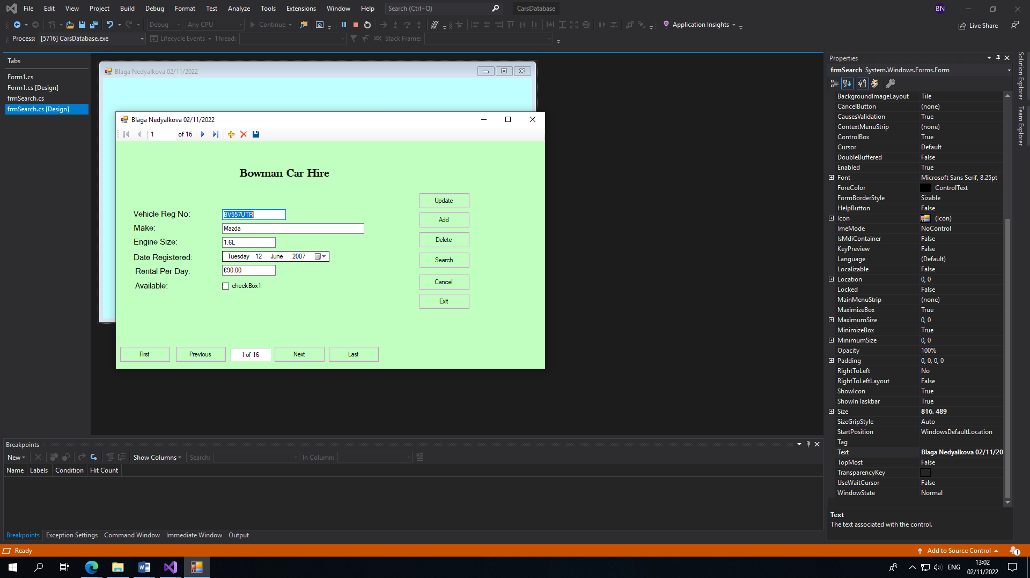

## Form 2

Main Purpose

The application scenario here is to display selected data on a form. Using parameterized queries helps make the application efficient by letting the database do the work it is best at — quickly filtering records.

**Search Criteria:** For example, we want to display the records for a specific customer or the details of a specific order. In this scenario, a user select information in a form frmSearch (File, Operator, Value), and then a query is executed with the user's input as a parameter; that is, the data is selected based on a parameterized query. The query returns only the data that satisfies the criteria entered by the user. This walkthrough shows how to create a query that returns customers specifications in a specific parameters query, and modify the user interface so that users can enter a cars details and press a button Run to execute the query.

**Display Results:** we are using Data Grids View to display the searched result data from a table in a grid-like format. The DataGridView control provides a customizable table for displaying data. The DataGridView class allows customization of cells, rows, columns, and borders through the use of properties such as DefaultCellStyle, ColumnHeadersDefaultCellStyle, CellBorderStyle, and GridColor.

**Screen Shot**

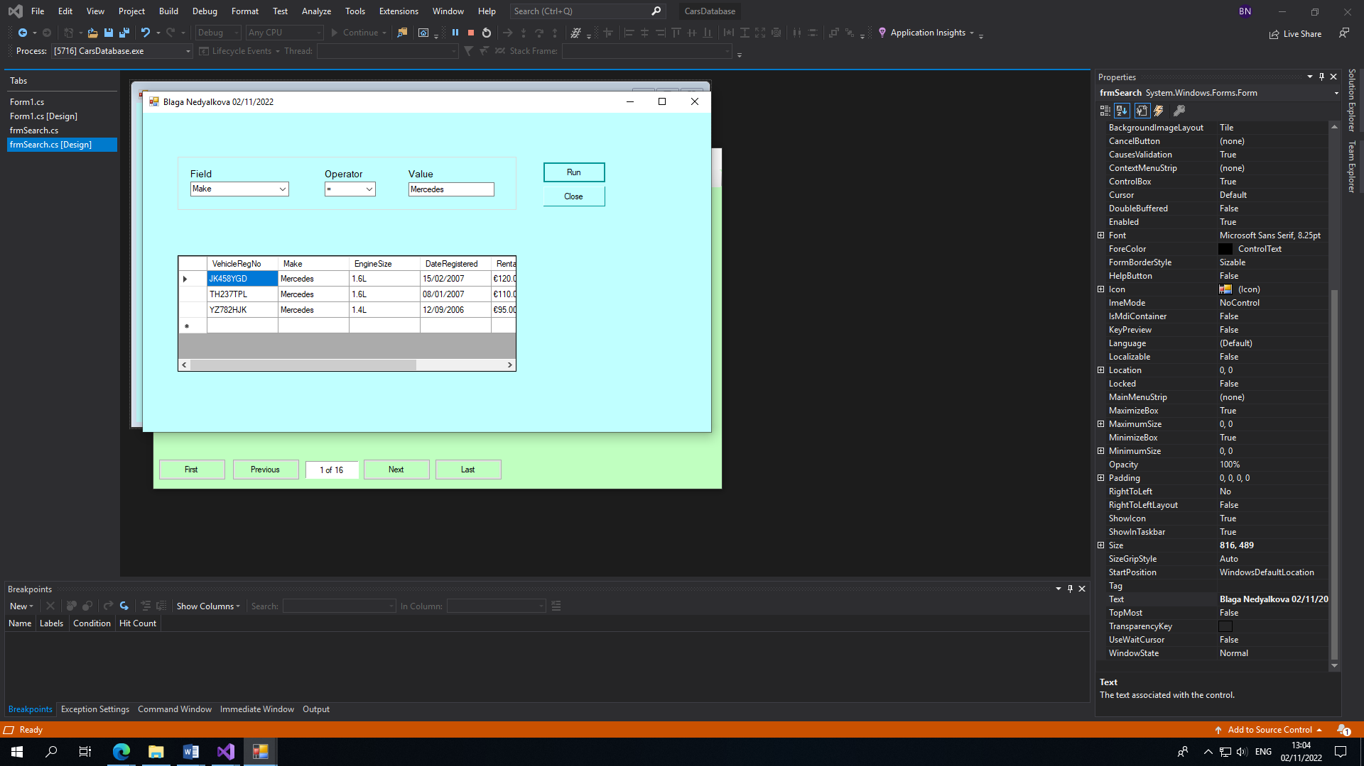

The user selects the criteria by choosing from the comboboxes the Field, Operator and the Value

·        Run – by click on the run button we are checking if the users criteria are true or false before being displayed in the data grid view.

·        Close - Hiding the control is equivalent to setting the Visible property to false. After the Hide method is called, the Visible property returns a value of false until the [Show](https://learn.microsoft.com/en-us/dotnet/api/system.windows.forms.control.show?view=windowsdesktop-6.0) method is called. The system will ask if the user wants to close this form of the project.

·        DataGridView - The GridView control presents a collection of items in rows and columns that can be scrolled vertically. Data is stacked horizontally until it fills a column, and then continues with the next row in the column.

## Test Plan

|  |  |  |  |
| --- | --- | --- | --- |
| **Software Component Name: frmStudents**  **Date:** | | **Version No: 1.0**  **Tester Name:** | **Page 1 of 2** |
| **Test No.** | **Purpose** | **Input** | **Expected Output** |
| 1.0 | Add  Valid record is saved | Click Add Button  Enter valid data  VehcleRegNo=  Make=  EngineSize=  DateRegistered=  RentalPerDay  Available  Click Update (Save)_ | Record added successfully to DB  Record Number increase by1  Newly added record is displayed |
| 1.1 | Add | Enter Data with invalid field | Record not written to DB because of the invalid data entry |
| 1.2 | Update | Save new record  Delete record  Click Update the record | Record is changed in database |
| 1.3 | Search  Bring the user to the second form to search for a record | Click on the search button | Brings the user to the search form |
| 1.4 | Cancel | Click on the cancel button after start filling the details to add new record | The record is not saved and the fields will be deleted |
| 1.5 | Delete  Successfully delete an existing record | Selecting a record that the user wants to delete using the navigation buttons. | message box will pop up  asking the user to confirm the deleting process  Clicking yes will remove that entry form the database |

|  |  |  |  |
| --- | --- | --- | --- |
| **Software Component Name: frmSearch**  **Date:** | | **Version No: 1.0**  **Tester Name:** | **Page 2 of 2** |
| **Test No.** | **Purpose** | **Input** | **Expected Output** |
| 2.1 | Run  Test the run features and make sure our search works correctly | Fill in the fields by selecting:  Field = Make  Operator= =  Value= Mercedes  Then Click Run | Results will populate the box with your filter results |
| 2.2 | Close  To Hide the program and display the first form frmCars | Click on the button Close | The program will display the message if you want to close the form |

## Test Results

I did make a test plan and I did test the program and all the features are working correctly. I did test if the data is loading in the correct format and with the correct fields. That means that we do have the correct connection to the database. The buttons are tested and working correctly. The customer expectations and requirements are met. I did test the program and is working correctly all the tests are passed. Test done 02/11/2022

* Displaying individual records in the textboxes with the 2 decimal point for the rental per day – pass
* Add a new record - textboxes are cleared and enable us to enter the new record. - pass
* Delete record – enable us to delete the existing record, but before to perform the action first asking us if we wish to proceed – pass
* Update – saving the added or deleted record - pass
* Cancel – able to cancel the amendments for a record – pass
* Exit – we exit the program successfully, but before closing the program is asking us for confirmation - pass
* Search – by clicking on this button we are redirected to the frmSearch where we are able to search for an existing records - pass
* Tested all the 4 navigating buttons - working correctly - pass
* The lable is displaying the correct number record of the total number of records - pass
* Data Grid Vies in frmSearch – displaying the searched records – pass
* Combo box Field – is enable you to choose one of the specified field names us required – pass
* Combo box Operator - enabling you to choose one of the operator symbols each one as a single list item as required – pass
* Value textbox – enable you to enter the searched value
* Tool tips set up – pass
* Input controls receiving focus in an appropriate order – pass

The program meets the customer specifications and requests:

* Program conform to the design specification
* The requests of the client is followed
* The names are per customer specifications and requirements
* The controls were chosen to be efficient, to be easy and clear to understand - meaningful names of the variables, forms, objects controls